


DSEU DWARKA CAMPUS

C PROGRAMMING
PRACTICAL FILE
Submitted in partial fulfilment of the requirements for
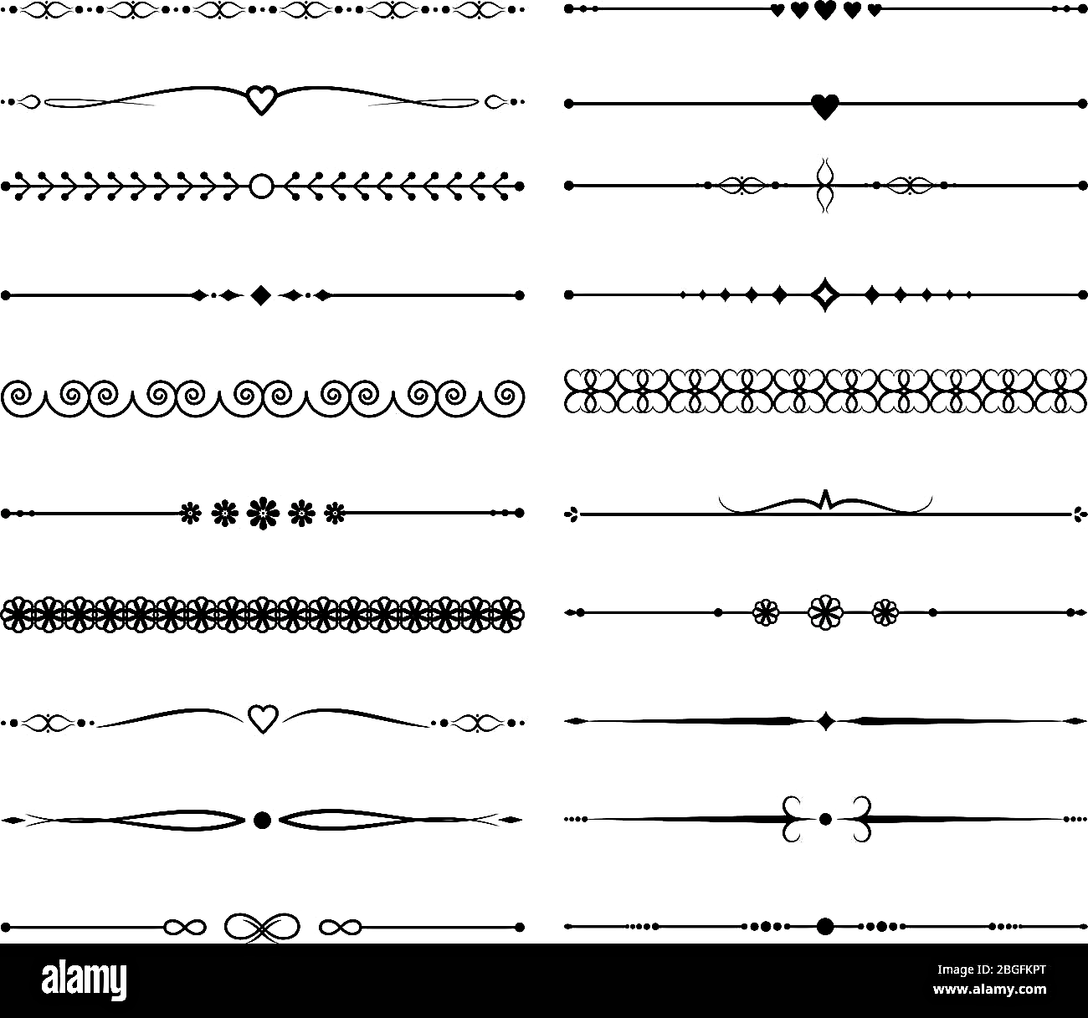


Course : _______________________
Semester : _______________________
Academic Session : _______________________


SUBMITTED BY
Name : ________________________
Roll no. : ______________________


SUBMITTED TO
Faculty Name : _______________________
Designation : _________________________

Question: Find maximum between two numbers.

Code:

#include <stdio.h>

int main()
{
int a, b;

printf("Enter a: ");
scanf("%d", &a);
printf("Enter b: ");
scanf("%d", &b);

if (a > b)
printf("Maximum is: %d\n", a);
else
printf("Maximum is: %d\n", b);

}

Output:

Enter a: 10
Enter b: 5
Maximum is: 10

Question: Find maximum between three numbers.

Code:

#include <stdio.h>

int main()
{
int a, b, c;

printf("Enter A : ");
scanf("%d", &a);

printf("Enter B : ");
scanf("%d", &b);

printf("Enter C : ");
scanf("%d", &c);

if (a > b && a > c)
printf("Maximum is A");
else if (b > a && b > c)
printf("Maximum is B");
else
printf("Maximum is C");
return 0;
}

Output:

Enter A : 10
Enter B : 20
Enter C : 30
Maximum is C

Question: Write a program to check whether a number is positive, negative or zero.

Code:

#include<stdio.h>
int main(){
int x;
int y;
int z;

printf("Enter the number: ");
scanf("%d", &x);

if(x<0){
printf("%d is a negative integer.", x);
}
else if(x>0){
printf("%d is a positive integer.", x);
}
else if(x==0){
printf("%d is a zero.", x);
}
else{
printf("Invalid character.!!");
}

}

Output:

Enter A : 10
Enter B : 20
Enter C : 30
Maximum is C

Question: Find maximum between three numbers.

Code:

#include <stdio.h>

int main()
{
int a, b, c;

printf("Enter A : ");
scanf("%d", &a);

printf("Enter B : ");
scanf("%d", &b);

printf("Enter C : ");
scanf("%d", &c);

if (a > b && a > c)
printf("Maximum is A");
else if (b > a && b > c)
printf("Maximum is B");
else
printf("Maximum is C");
return 0;
}

Output:
Enter the number: -4
-4 is a negative integer.

Question: Write a program to check weather an integer is even or odd.

Code:

#include<stdio.h>
int main(){

int x;

printf("Enter a number: ");
scanf("%d", &x);

if(x%2==0){
printf("%d is an even number.!", x);
}
else if(x%2!=0){
printf("%d is an odd number.!", x);
}
else{
printf("Invalid character.!!");
}
}

Output:

Enter a number: 6
6 is an even number.!

Question: write a program to check weather a character is alphabetic or not.

Code:

#include<stdio.h>
int main(){
char x;

printf("Enter the character: ");
scanf("%c", &x);

if(x>='a' && x<='z'){
printf("This is an alphabetic character.");
}
else{
printf("Invalid character.!!");
}
}

Output:

Enter the character: d
This is an alphabetic character.

Question: Write a program to input an alphabetic character and check weather it is vowel or consinent.

Code:

#include<stdio.h>
int main(){
char x;

printf("Enter the character: ");
scanf("%c", &x);

if(x>'a' && x<'z' || x>'A' && x<'Z'){
if(x=='a' || x=='e' || x=='i' || x=='o' || x=='u' || x=='A' || x=='E' || x=='I' || x=='O' || x=='U'){
printf("%c is an vovel.!", x);
}
else if(x!='a' || x!='e' || x!='i' || x!='o' || x!='u'){
printf("%c is a consonent.", x);
}
}
else{
printf("Invalid character.!!");
}
}

Output:
Enter the character: U
U is an vovel.!

Question: write a c program to input a charcutier and check whether is alphabet or special character.
Code:

#include<stdio.h>
int main(){
char x;

printf("Enter a character: ");
scanf("%c", &x);

if(x>='a' && x<='z' || x>='A' && x<='Z'){
printf("%c is an alphabetic character.", x);
}
else if(x>='0' && x<='9'){
printf("This is a numerical character.", x);
}
else{
printf("This is an Special Character.!!");
}
}

Output:
Enter a character: 34
This is a numerical character.

Question: Write a c program to check whether a character is upper case or lower case.
Code:

#include<stdio.h>
int main(){
char x;

printf("Enter an alphabet: ");
scanf("%c", &x);

if(x>='a' && x<='z'){
printf("%c is an Lower Case Alphabet.", x);
}
else if(x>='A' && x<='Z'){
printf("%c is an Upper Case Alphabet.", x);
}
else{
printf("Invalid / special character.!!");
}

return 0;
}

Output:

Enter an alphabet: b
b is an Lower Case Alphabet.

Question: write a c program to input week number and print week day.
Code:

#include<stdio.h>
int main(){
int x;

printf("Enter day number: ");
scanf("%d", &x);

if(x >= 1 && x <= 7){
if(x==1){
printf("The day is Monday.");
}
else if(x==2){
printf("The day is Tuesday.");
}
else if(x==3){
printf("The day is Wednesday.");
}
else if(x==4){
printf("The day is Thursday.");
}
else if(x==5){
printf("The day is Friday.");
}
else if(x==6){
printf("The day is Saturday.");
}
else if(x==7){
printf("The day is Sunday.");
}
}
else{
printf("Enter a number between 1 to 7");
}
}

Output:

Enter day number: 4
The day is Thursday.

Question: write a c program to input month number and tell how many days are in that month.
Code:

#include<stdio.h>
int main(){
int x;

printf("Enter teh month number: ");
scanf("%d", &x);

if(x>=1 && x<=12){
if(x == 1 || x == 3 || x == 5 || x == 7 || x == 8 || x == 10 || x == 12){
printf("This month have 31 days.");
}
else if(x == 4 || x == 6 || x == 9 || x == 11){
printf("This month have 30 days.");
}
else{
printf("This month have 28 days (If not a leap year).");
}
}
else{
printf("Enter a number between 1 to 12");
}
}

Output:

Enter the month number: 9
This month have 30 days.

Question: write a c program to input angles of a triangle and check whether the triangle is valid or not.
Code:

#include<stdio.h>
int main(){
int x;
int y;
int z;

printf("Enter First angle: ");
scanf("%d", &x);

printf("Enter Second angle: ");
scanf("%d", &y);

printf("Enter Third angle: ");
scanf("%d", &z);

if(x>0 && y>0 && z>0){
if((x+y+z)==180){
printf("These angles will make an triangle.");
}
else if((x+y+z)!=180){
printf("These angles will not make a triangle.");
}
else{
printf("Invalid Input.");
}
}
else{
printf("Invalid input.");
}
return 0;
}

Output:

Enter First angle: 50
Enter Second angle: 60
Enter Third angle: 70
These angles will make an triangle.

Question: write a c program to check whether the triangle is isosceles or equilateral
Code:

#include<stdio.h>
int main(){
int x;
int y;
int z;

printf("Enter First angle: ");
scanf("%d", &x);

printf("Enter Second angle: ");
scanf("%d", &y);

printf("Enter Third angle: ");
scanf("%d", &z);

if((x+y+z)==180 && x>0 && y>0 && z>0){
if(x==y && y==z && x==z){
printf("This is an Equilateral Triangle.");
}
else if((x==y) || (y==z) || (x==z)){
printf("This is an Isosceles Trianlge.");
}
else{
printf("This is a Scalene Triangle");
}
}
else{
printf("These angles will not make a Trianlgle.");
}
}

Output:

Enter First angle: 50
Enter Second angle: 65
Enter Third angle: 65
This is an Isosceles Trianlge.

